Sure, tuition is expensive, but you shouldn't feel like your ship is sinking.

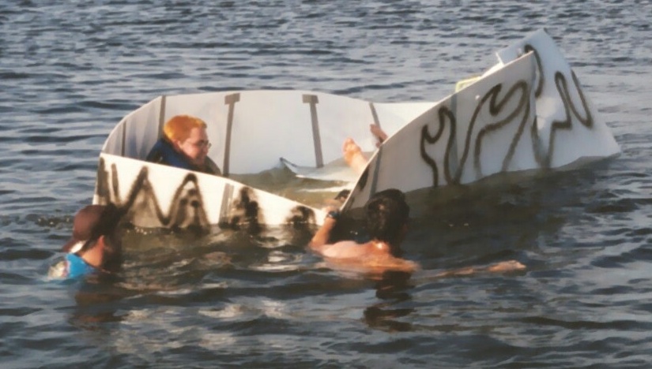

On February 14-15, vote Will Matheson for VP External Affairs.

willmatheson.com/vpexternal

